District Advisory Council Minutes
January 28th, 2021

The meeting was called to order at 6:00 pm by Chairperson, Steve Dobbs, and the following people were in attendance:
Ken Kenworthy, Superintendent, Pat McCoy, Assistant Superintendent, Dylan Tedders, Assistant Superintendent, Steve Dobbs, Chairman, Lisa Bell, Secretary, Ellen Williams, representative from Yearling Middle School, Cheryl Hollin, representative from Everglades Elementary, Tuuli Robinson, Principal from North Elementary, Alyson Shirley, Assistant Principal from North Elementary, Heather Siler-Dobbs, Director of Grants and Special Programs, Dan Thomas, representative from Virtual and OAA, Sean Downing, Principal from Osceola, Anna Huerta, Migrant Advocate from High School and SAC Chairman from Freshman Campus, Marnie Ayers, ESE from Yearling Middle School and Cheryl Hollin, representative from Everglades Elementary,Vicki Goggans, Freshman Campus Principal, Hope Sheppard, TSA Grants and Special Programs

Mr. Dobbs asked for a motion to approve the written minutes from the last meeting. A motion was made by Heather Siler-Dobbs and seconded by Anna Huerta.

Heather Siler-Dobbs spoke to us about the B.U.D.D.Y. Mentoring Program. This program has been researched and is being developed for our District by Heather Dobbs, Pam Hancock, Erin Moore, Alexandra Navarette, and Hope Sheppard. B.U.D.D.Y stands for Building Up Diverse and Dynamic Youth and the B.U.D.D.Y. Team is looking for mentors! Mentors make a huge difference in the lives of students. This program will provide a buddy for every student, starting at Central Elementary Fifth graders. Our district has a low income poverty level of between 54 and 77% depending on which school population we are looking at. This qualifies us for the Title I funding for the program. Students who are assessed as being in the most need will be identified. Mentors, who will be matched to these students, meet the student on campus for 30 minutes each week at a time that does not pull them from class or take them away from structured learning time. Consistency and dedication to be committed for one year is the most important factor of a successful mentorship. Interested persons will go through a 3-part screening process and fill out an application that includes questionnaires .

Each mentor will receive a manual, toolkit of ideas, 12 hours of training and will go through orientation at the school where their student goes. Training will include ground rules, reporting child abuse and Check and Connect Training. Check and Connect Training is a researched based training designed to systematically monitor students and personalize the intervention with a focus on enhancement skills.

Mentors are encouraged to have great parent contact throughout the program from the very beginning to the end. Involvement and good communication with the student’s parent/guardian plays a very important role in the success of new enhancement skills the student might be learning. No experience? No Problem! All adults are encouraged to consider being a mentor.

Link to sign up: bit.ly/BUDDYMENTORING
Questions contact: Kathy Williams at Williamsk@okee.k12.fl.us 863-462-5000 x 1040 or Heather Siler-Dobbs at Heather.Siler-Dobbs@okee.k12.fl.us

Questions and Comments:
Q. Marnie Ayers asked if her application was accepted, would she have to be with her student in person or would zoom or electronic meetings be okay.
A. Electronic visits can work

C. Steven Dobbs commented from the perspective of his position on the Economic Council and his contacts with parents, that this is such an excellent way to help children achieve.
C. Pat McCoy commented that even great parents need help sometimes to help their own children succeed.
C. Heather Siler-Dobbs echoed Mrs. McCoy’s comment, that she remembered dismissing her parents’ instruction but when another person said the same thing verbatim, she thought it was just earth shattering!

Q. Dan Thomas wanted to know if there was an expiration date on the Check and Connect Training. He has already had the training but wondered if he would need to take that again.
- Mrs. Dobbs was not sure but would check into it.

Q. Steven Dobbs questioned if he would have to be finger printed again, since he already has been as a contractor.
- Mr. Kenworthy remarked that fingerprinting would have to have been set up by the school district and outside of district fingerprinting would not be recognized. He felt that if OCSB has done the fingerprinting, it would be acceptable but the question would be asked and response given.

Next Dylan Tedders remarked about the Climate Surveys. The surveys did not go out last year because of COVID and the fact that parents had been at home with their children. The District felt that it would have been the wrong time. He described the surveys and number of questions each group is currently answering and then spoke about the desire of the District to get the surveys down to the individual teacher levels. However, if for example, high school students were answering a high number of questions overall, would they be willing to answer those questions over and over for each and every teacher. It would take some time and would there be a willingness on the part of the student or the parent to answer in full. We just aren’t at that point in the development of the survey yet. Mr. Tedders has been soliciting administrative feedback on this topic and he commended Sean Downing and Tuuli Robinson, principals at Osceola Middle School and North Elementary School, respectively, for their feedback and investment in the process to date.

Questions and Comments:

C: Lisa Bell commented that at an earlier appointment that evening, she had been cornered on four sides by the staff at the doctor’s office. It started with the doctor and spilled over into the reception area where the comments were that we were not asking the right questions on the surveys, we were not giving them opportunities to give feedback and that there were no PTO or SAC meetings in order to discuss these things. The office reception staff members felt that our communication was not good at all, that we gave them just the bare information and did not provide the opportunity for them to be heard.
Mr. Tedders highlighted the opportunity given on the webpage but said that it was the same handful of parents who ever responded or gave feedback. He also reminded us that anyone can email Okee.Helpdesk@okee.k12.fl.us to offer suggestions or comments as they wish.
Heather Siler-Dobbs asked if Skyward, our student information system could do any texts blasts. Mr. Dobbs said yes and we do use it, but again, parents can opt out and we end up with the handful that interact with us.

C. Steven Dobbs commented that he would love to get the survey to the members of the Economic Council.

Next up, Mr. Kenworthy shared some District data and a COVID update. He started by telling us that the Board had approved our Strategic Plan at the January 19th meeting and that we had, had our first examination, if you will, of the metrics based on the strategies. This information was posted on our website and will be posted in a new program we are using called, BoardDocs. BoardDocs is an online paperless platform for the operation and management of school board meeting minutes with tabs devoted to Strategic Plans and Policies for public examination. There are great search features that make this App really nice going forward, which make it possible for individuals to look up information for any point in time.

The graduation rate has gone up. Although this is great news, Mr. Kenworthy tempered it with the reminder that last year, due to COVID the Florida Standard Assessments (FSA) Test was waived. Our YOY graduation rate and comparison to the state rate looked like this:

State 2018-19 SY 75.8% vs. OKEE 79.8%
State 2019-20 SY 84.2% vs. OKEE 87.6%

Compared to the state rate we are not where we need to be. While our rate is higher than our neighboring Highlands County, it is lower than most other Heartland and Treasure Coast Districts. One could say that while we are closing the gap, we still have a long way to go.

Some good news to report regarding special facilities. We were ranked by FDOE as 2nd in critical need for funding. While that in itself is not good news, the funding for building is. In light of this ranking, we put out a Request for Quote, (RFQ) for architectural services. We are now in negotiations with the one that ranked highest. We are also now in lobbying efforts for money.

On the COVID front, there was an article in the local newspaper yesterday regarding our exclusions. There has been some talk to the effect that we are trying to cover up our number of cases and exclusions, but we have had this full disclosure on the homepage of our website- right on the dashboard. To date we have excluded 1453 students and 108 employees. We have had 119 positive cases among our students and 34 employees. Currently we are doing Robo calls to assist the Department of Health (DOH) with notification to parents regarding exclusions. The DOH is focused more on vaccinations at this time and so we are assisting to get the word out to our families immediately.

WIth regard to our Budget, the governor just released his budget today and his base student allocation (BSA) increase is very favorable over the recommendation from the Commissioner of Education. The BSA, or the money we receive for every enrolled student, recommendation from the Commissioner of Education is a $10.00 increase, whereas, the recommendation from Governor Desantis is an increase of $132.00. The governor’s budget will not be approved as it is, but we are hopeful that with the variance, we will receive more than the $10.00 recommendation by the Board of Education. Guardian funding is back in the total funds, as well as, increased Mental Health funding by $10,000,000. The not so good news that plays a factor is that even though we are back to 90.4% of our students in Face2Face learning, we lost enrollment because of COVID. The closure of the Department of Juvenile Justice School (DJJ) brought in 150 more students, but Virtual School took some of them. Still there is a small number of students that we haven’t been able to locate yet. Where did they go? What are they doing with regard to education. Our projected enrollment for 20-21 SY will go under 6,200 or 7% down from the current year. This will equate to a nearly 3 million dollar loss in funding. The good news is that we will end the year with a healthy fund balance going into next year.

Dr. Pat McCoy presented testing and progress reports next. i-Ready Reading and Math screenshots inserted below.

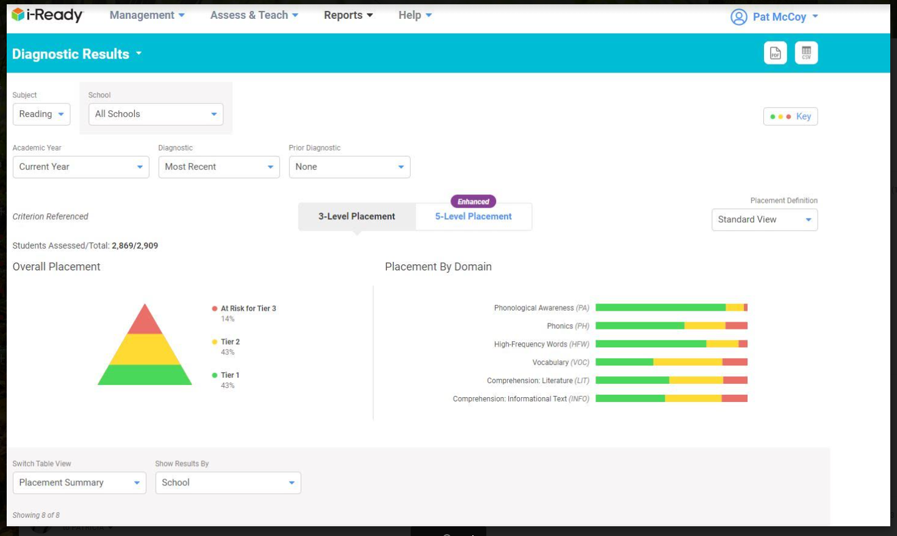

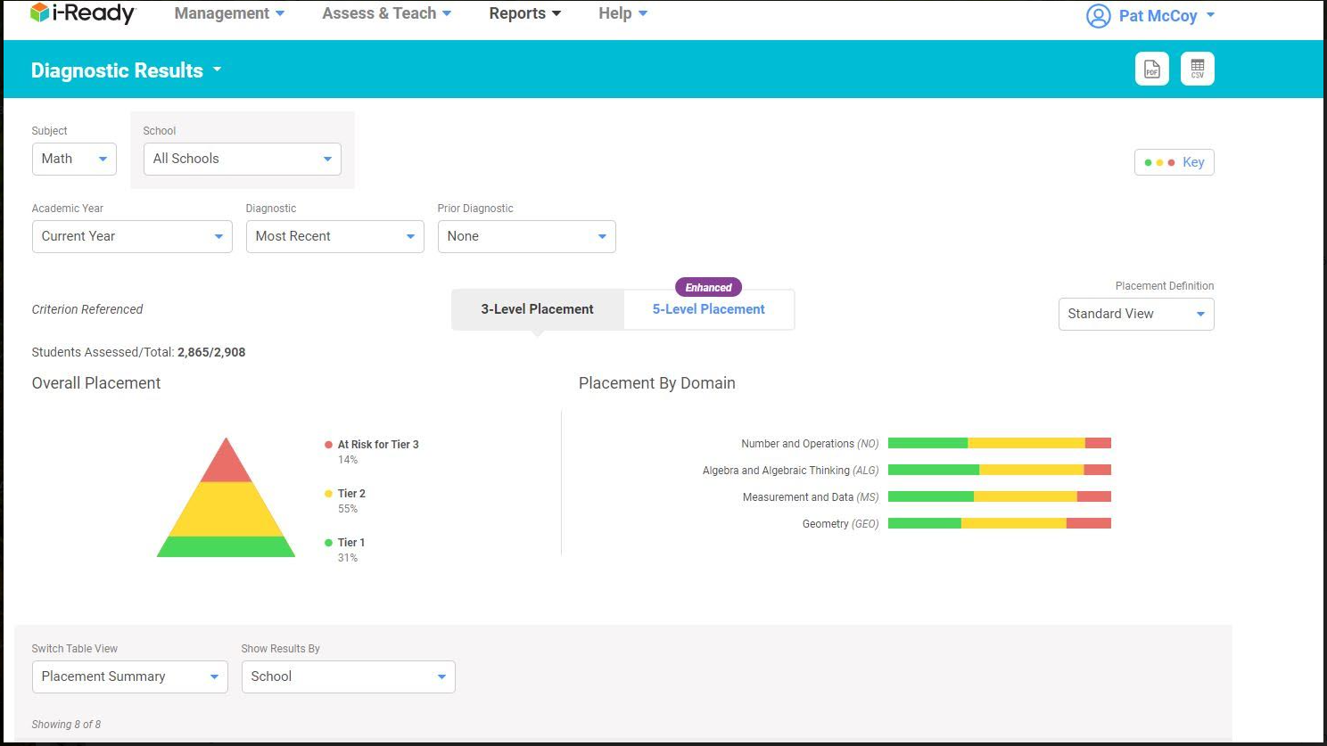

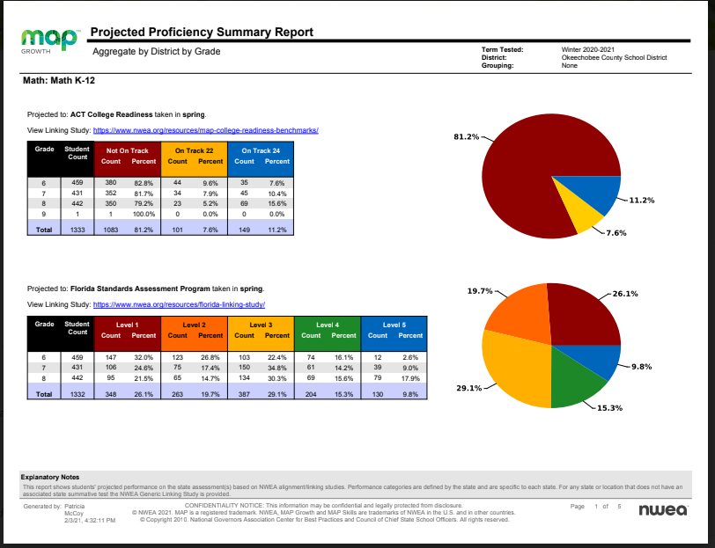

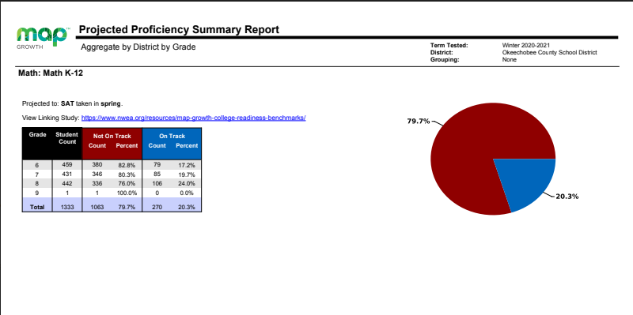

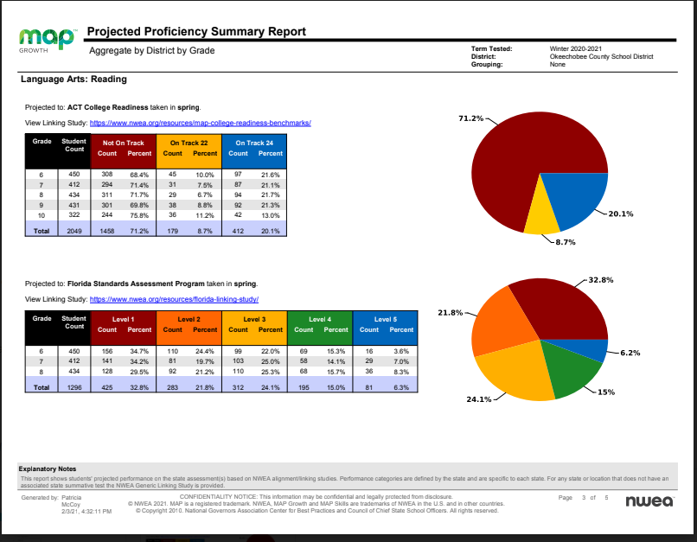

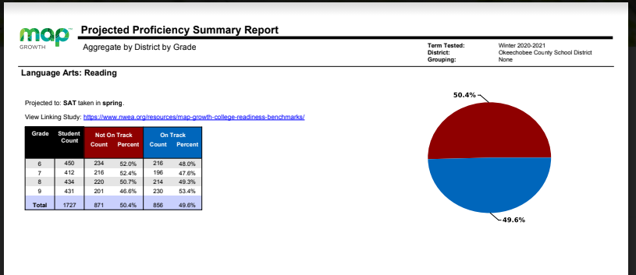

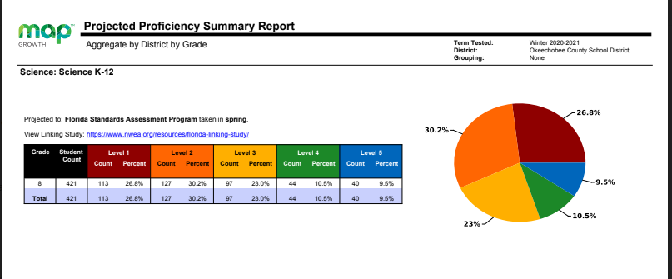

Following Dr. McCoy’s presentation, Heather Siler-Dobbs had a challenge for us regarding Parent and Family Engagement. She presented information about a Global Family Research Project called “Joining Together to Create a Bold Vision for Next Generation
Family Engagement”
https://globalfrp.org/content/download/419/3823
/file/GFRP_Family%20Engagement%20Carnegie%
20Report.pdf

Of the 6000 waking hours that students have in a year, they spend 5000 hours outside of school. There are opportunity gaps within those hours, especially for low income households. There is a $7900.00 gap between what high income families spend on extracurricular activities that low income families can afford to spend. Family/School partnerships can make up for that gap. In this research study there is a case-in-point in the study of Zavala Elementary School: Central East Austin, TX. They went from high teacher turnover to low teacher change,33rd of 63 schools in attendance to first place in the district, test scores at half the district average to exceeding the city-wide average all because of parent leadership and advocacy. Heather referenced Lisa Bell’s earlier comments regarding the feeling that parents were not being heard, not being asked for input, and not offering opportunities and highlighted these words in your closing: “Open Forum”, “Gather Information”, “Seek Input”, “Greater Cooperation”, “Develop United Efforts”, “Increase Involvement”. These were all words that she pulled from other Florida District Advisory Council Mission Statements. “It starts with listening. This is huge in low parent participation. We can’t assume that lack of participation is because of the lack of caring.” Her challenge to the team was to read the document and think about asking parents more questions about what we can do to help them help their children.

SCHOOL HIGHLIGHTS

OAA: Audie Ash caught us up on the happenings at Okeechobee Achievement Academy and Virtual School. The REACH program has 6 previously retained 9th graders who reached their goals and will return to the Freshman Campus at the end of the semester. Fourteen others are on track to become 11th graders by August. Additionally, a middle school REACH Program was just started and there are 6 students and they have a goal that this time next year they will be second semester 10th graders… yes, they are on a path to skip a grade!

The GAP Program seniors who were in jeopardy of not graduating were placed in the accelerated program with 14 meeting the requirements. Eleven will graduate in December. Twenty more are working toward that goal with 40 to become graduates.

In Virtual School, the first semester was an adjustment period to say the least. Many students realized that virtual learning was not for them.

Tutoring started on Tuesdays and Thursdays with 20-30 students. Last quarter 100% of those who consistently attended their tutoring sessions, made the A/B honor roll.
Audie, please fill in what you said the contribution was from Marnie Ayers and Dan Thomas. I missed it. _Marnie Aters started a new literacy read aloud program at OVS. All grade levels can login into a zoom session and participate in a read aloud with an age appropriate, fun, and interesting book.

EES: Everglades is celebrating Literacy Week by holding an AR challenge, doing classroom reads, and having bulletin boards focus on reading. The Literacy First coach will be back at EES in February for coaching and feedback which students and staff are very excited about.

FRESHMAN CAMPUS: Vicki Goggins reported that 88% of 1st semester students were on track to promote to 10th grade. OFC is working with OAA as a partner through REACH to possibly allow the remaining 12% to earn their promotion.

Additional tutoring funds to use during 7th hour, have come through. Twenty-five of the highest impacted students will work daily Monday -Thursday, towards credit retrieval and hopefully pre-empt that summer lag.

Discipline, she is happy to report, is down. Referrals are ⅔ less than this time last year. Mrs. Goggins gave Nicole Smith, Assistant Principal, much credit for using the Restorative Referral Process.

OMS: Mr Downing said that Osceola was excited about the numbers coming out of the ELA and Math Winter Growth Targets. Overall 61% of ALL students showed growth. Our Tier 3 students, or the neediest academic students in ELA, had 84% show growth from test 1 to test 2. Overall, our math had about 79% of students show growth from test 1 to test 2.

Basketball season is now complete and softball season is up to bat!

NES: Tuuli Robinson’s excitement was from the new staff members she has been able to add to North Elementary. Voluntary collaborative professional learning sessions have been started and are on-going each Monday. Teachers who participate, receive a badge to display on their door to show their participation. This has caught on with other teachers, who would also like to show their cooperation and is going very well.

The data for our APM (Adaptive Progress Monitoring) assessments is as follows:
3rd grade ELA proficiency:
- School 47%
- District 41%
- State 35%
4th grade ELA proficiency:
- School 46%
- District 36%
- State 35%
5th grade ELA proficiency:
- School 28%
- District 34%
- State 37%
These are optional FSA style assessments from DOE, demonstrating students' current levels of performance on FSA like content in ELA and math.

New Tutoring classes starting next week, lifting up our 3rd grade population who are in Tier 1 now in hopes of getting a head start with this group.

There was no new business and the meeting was adjourned by Mr. Dobbs at 7:30

