HMH – Florida Collections
Viewing Interactive Lessons using SMART Express on your Promethean Board

- Log in to HMH at my.hrw.com using your login and password.
- Select the yellow “Teacher Resources” from the Resources Section. 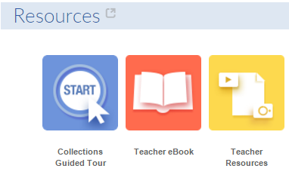

- In the new tab click on Interactive Whiteboard Lessons. 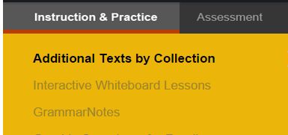

- Select “Explore all presentations and teacher resources >” 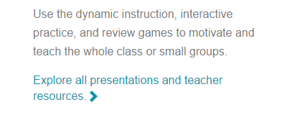
- Click on the Interactive Whiteboard Lesson that you want to use. Then click on Lesson under Downloads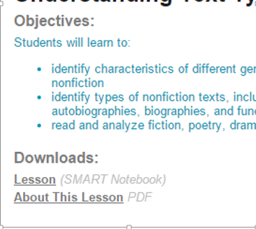

- The lesson will download, and it will save in your download folder.
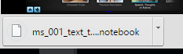

- In a new tab in your browser (it works in Chrome) go to http://express.smarttech.com/#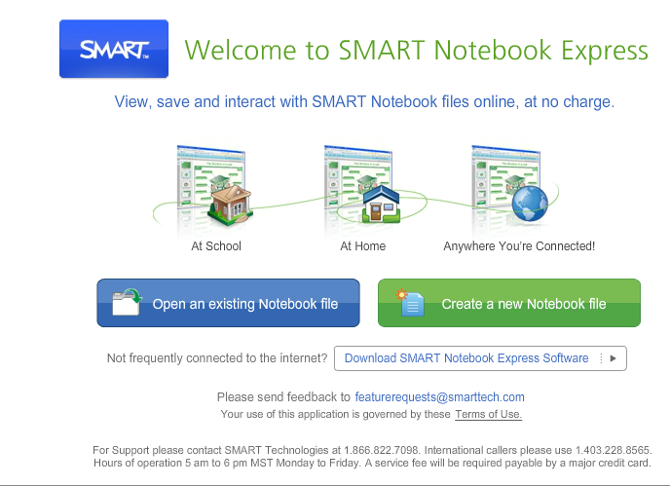

- Click on Open an existing Notebook File, and your Downloads folder will open. Select the lesson that you want to open. The computer will open the file for you to use in SMART Express. It takes a few minutes to open.

